Question 1
Q. What Is React Router? How Does It Handle Routing In Single-Page Applications?
Ans : React Router Is A Popular Library Used For Implementing Navigation And Routing In React.
It Enables Single-Page Applications (SPAs) To Have Multiple Views Without Reloading The Entire Page.
How It Works:
- React Router Uses The Browser’s History API To Navigate Between Components Without Refreshing The Page.
- It Matches The Current URL Path With The Defined Routes And Renders The Corresponding Component Dynamically.
- This Provides A Seamless, Fast User Experience Similar To Multi-Page Apps But Within A Single HTML Page.
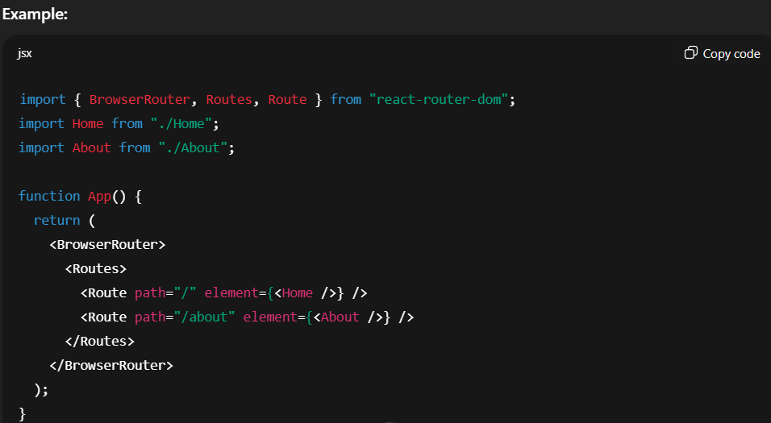

Question 2
Q. Explain The Difference Between BrowserRouter, Route, Link, And Switch Components In React Router.
Ans :
Component | Description | Example Usage
BrowserRouter | Wraps The Entire Application And Keeps The UI In Sync With The URL. Uses The HTML5 History API. | <BrowserRouter>...</BrowserRouter>
Route | Defines A Path And Specifies Which Component Should Render When The URL Matches. | <Route path="/home" element={<Home />} />
Link | Used For Navigation Without Page Reload. Replaces The Traditional <a> Tag. | <Link to="/about">About</Link>
Switch (v5) / Routes (v6) | Ensures Only The First Matching Route Is Rendered. In React Router v6, Switch Is Replaced By Routes. | <Routes><Route path="/" element={<Home />} /></Routes>

